 **St. Gabriel Parish**

**Youth Ministry Newsletter**

February 2022



Serving God by Serving Community

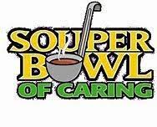

This month’s Service Project: Annual Souper Bowl Collection at both Masses on February 12th and 13th. Students will be stationed at both entrances of the Church after both Masses collecting monetary donations to support the East Side Soup Kitchen. As always, service projects reinforce the importance of our Theology of the Body discussions as we serve God with all that we are and through the use of our whole body - hands, eyes, heart and minds as we serve others in our community and beyond.

**UPCOMING EVENTS**

**\*\*PLEASE NOTE**, due to recent cancelations, there are changes to our originally scheduled activities, however, the calendar dates remain the same. Unfortunately, this pandemic continues to impact us and, as always, our priority is the health and safety of our Church families.  We will continue to follow the BCPS closings as announced. We appreciate your understanding and continued support as we continue to find ways to keep our youth connected and engaged in their Faith journey.

***February 6*** – Speaker, Coach Chris Willertz

***February 12 & 13*** – Service Project: Souper Bowl Collection after both Masses

***February 20*** – NO Class – BCPS OFF

***February 27*** – Classwork: Theology of the Body

Just a reminder that HIGH SCHOOL STUDENTS WILL BE MEETING IN THE RECTORY BASEMENT. Middle School will continue to meet in the Social Hall. As we will be dividing classes up more, we are in need of a few volunteers to assist with the groups. Please call the Parish Office if you are interested in helping. Thank you!

________________________________________

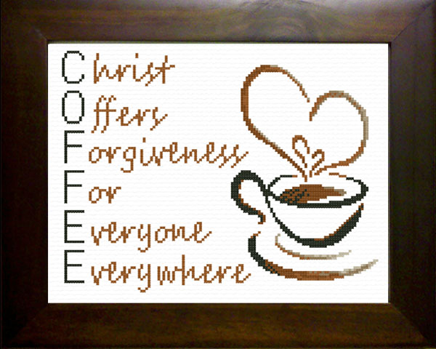

**Every Friday Night 7-11:30 pm** – Christian Coffeehouse, 2305 South Monroe St., Bay City. Open to ALL High School students. Check out their Facebook page for entertainment schedule and details at www.facebook.com/thechristiancoffeehouse.

***1 Corinthians 13:4-5****: Love is patient, love is kind. It does not envy, it does not boast, it is not proud. It does not dishonor others, it is not self-seeking, it is not easily angered, it keeps no record of wrongs.*

STUDENT SECTION

**All About Learning** – Our studies continue to focus on John Paul II’s Theology of the Body and will do so through the end of the year as these talks are so important and relevant to our youth today. We will be utilizing a high school and middle school curriculum by Ascension Press.

\***Please let us know if you are interested in the parent edition.**

**Talking Points for your Family:**

~What are Fr. Mike’s 5 points?

~ Social acceptance does not equal God acceptance.

~Struggling with answers to difficult questions in our society, explore the response and truths behind ”In the beginning, it was not so.”